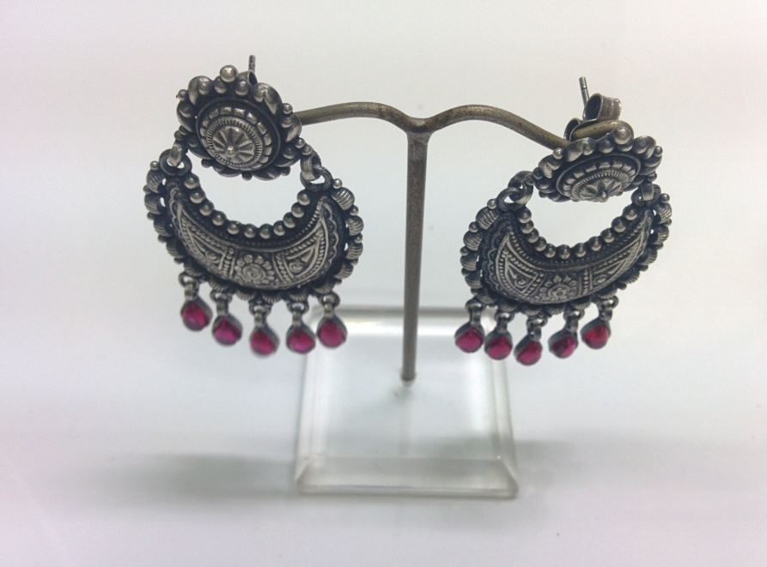
Sr No.- LWE01 Wght: 19.5 gms

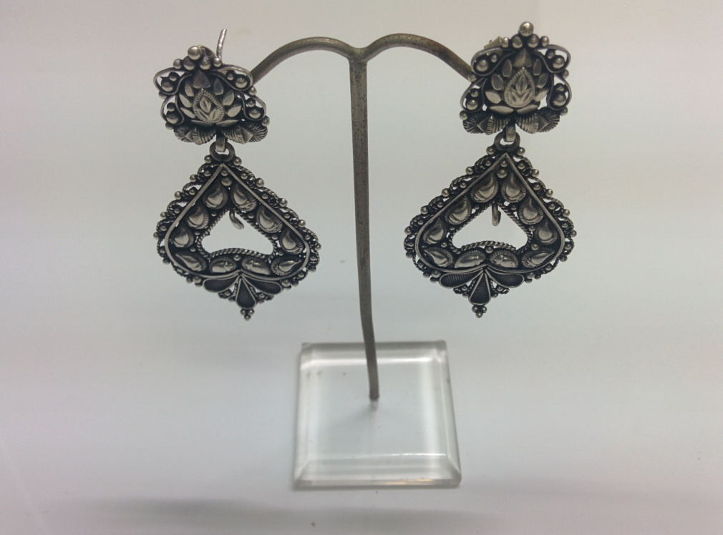
Sr No. – LWE02 Wght: 16.1 gms

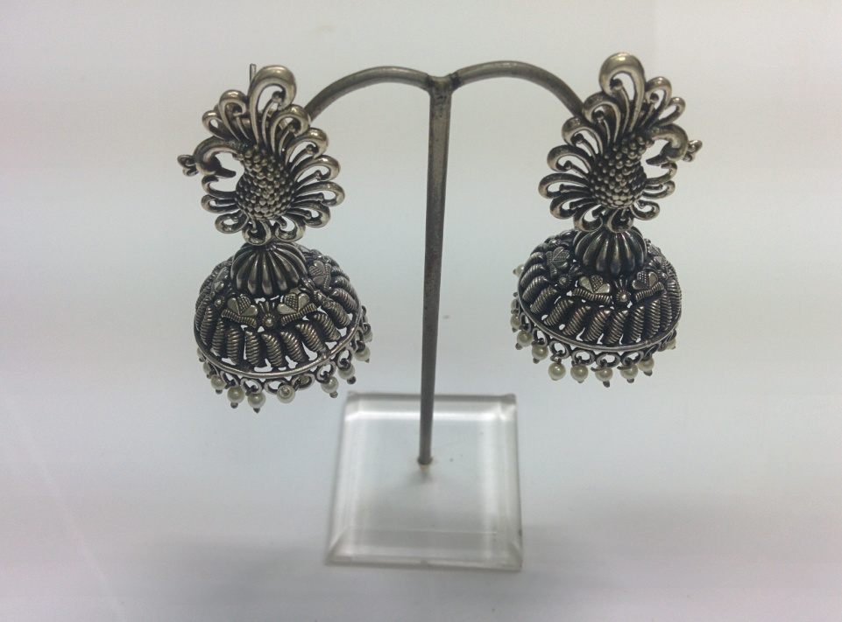
Sr No. – LWE03 Wght: 20.4 gms

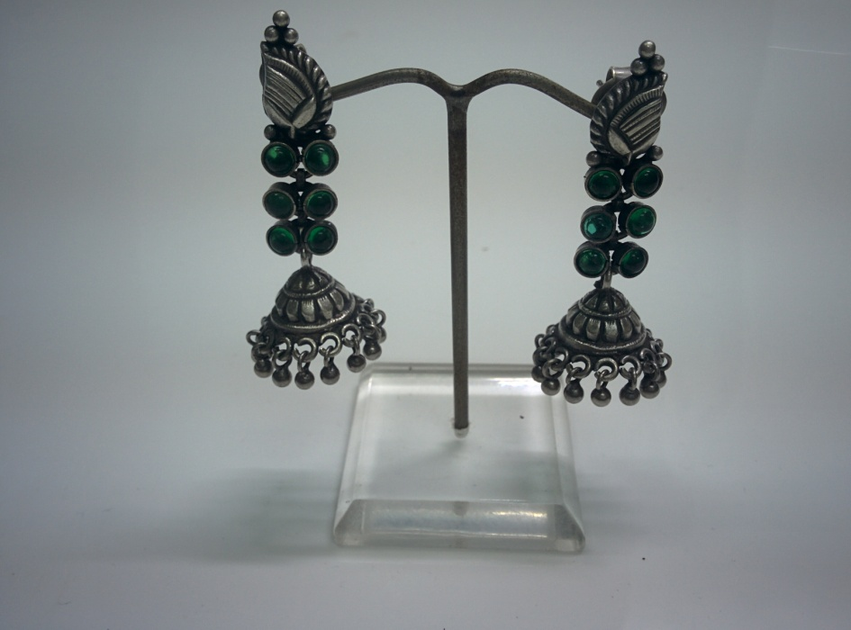
Sr No. – LWE04 Wght: 16.7 gms

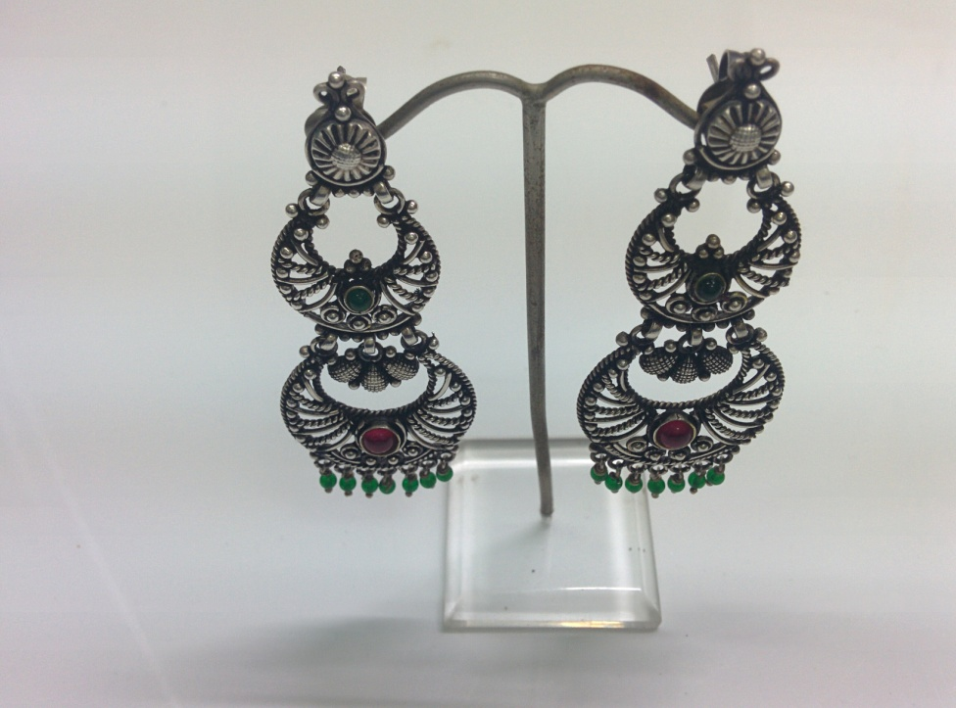
Sr No. – LWE05 Wght: 26.1 gms

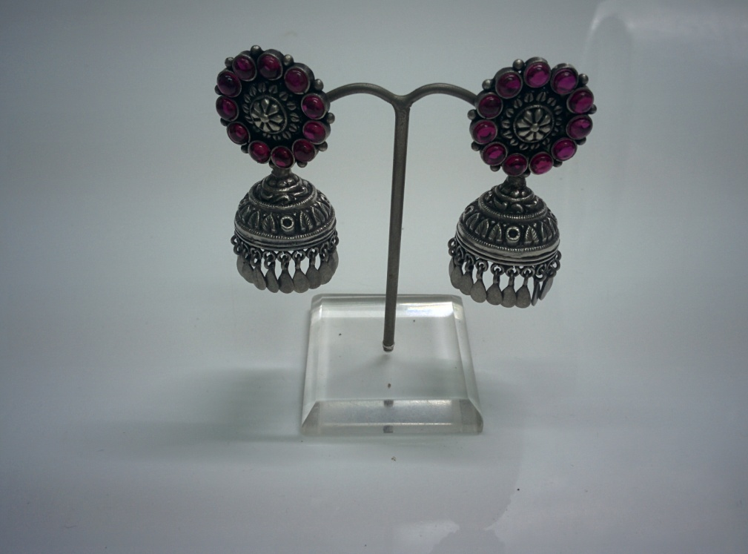
Sr No. – LWE06 Wght: 29.3 gms

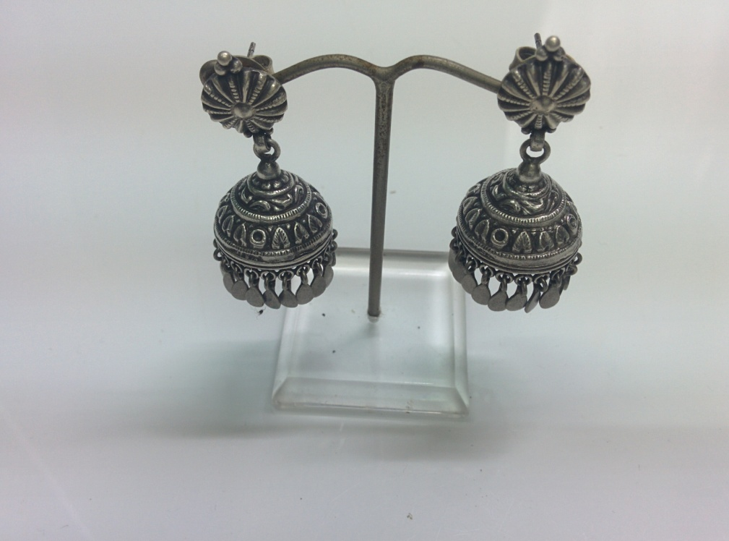
Sr No. – LWE07 Wght: 22.2 gms
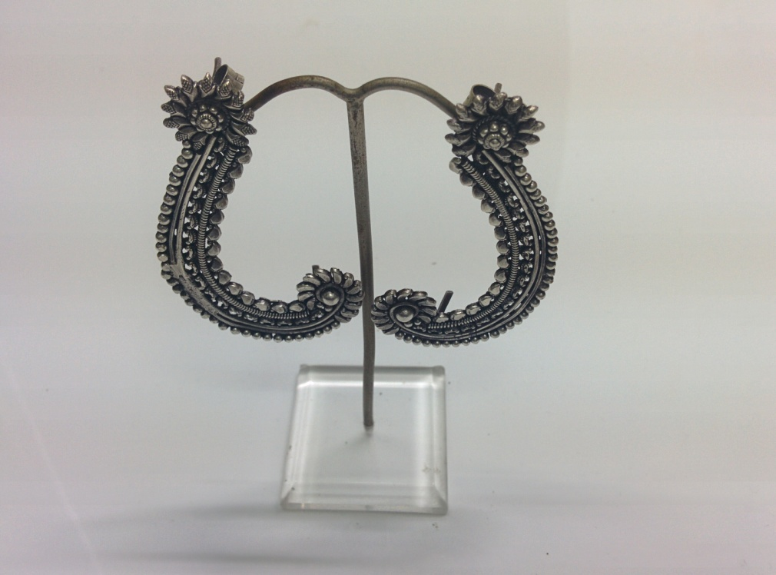
Sr No. – LWE08 Wght: 20.3 gms

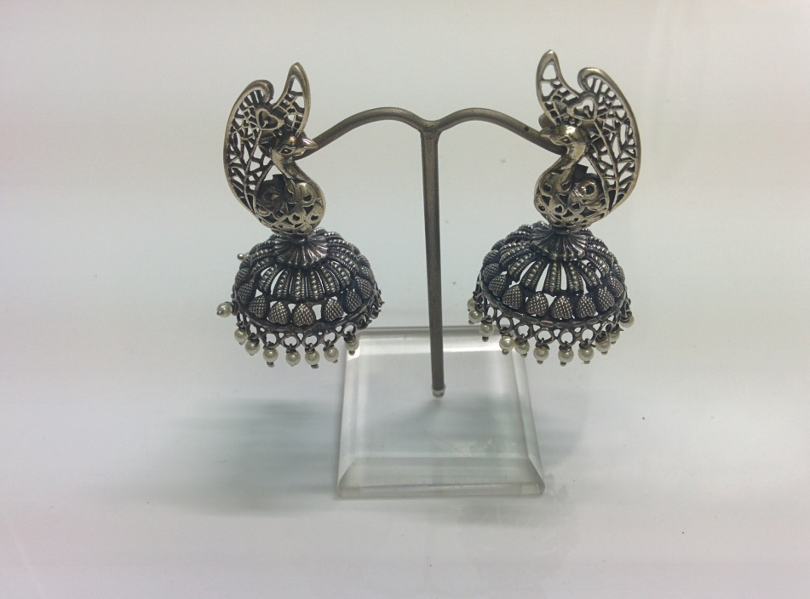
Sr No. – LWE09 Wght: 21.5 gms

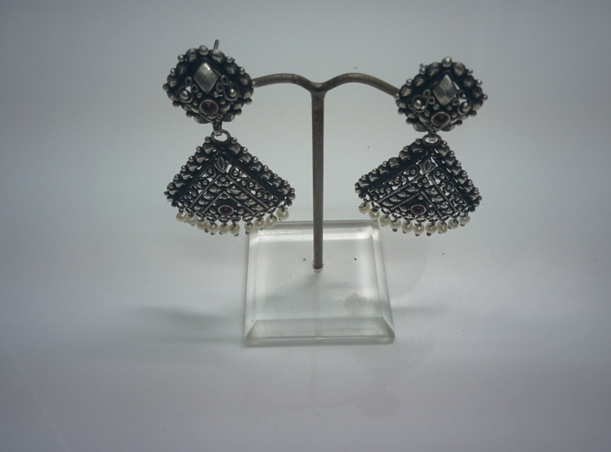
Sr No. – LWE10 Wght: 18.2 gms

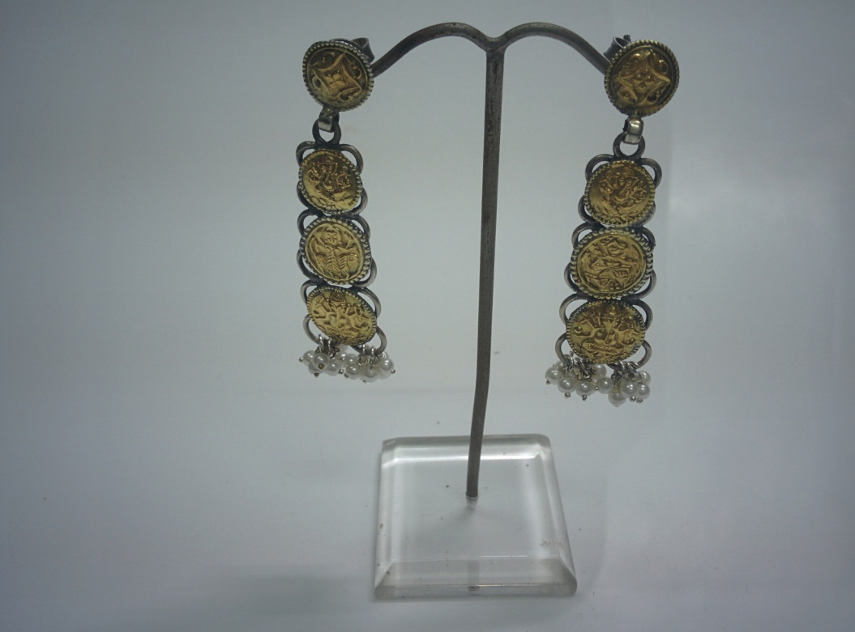
Sr No. – LWE11 Wght: 14 gms

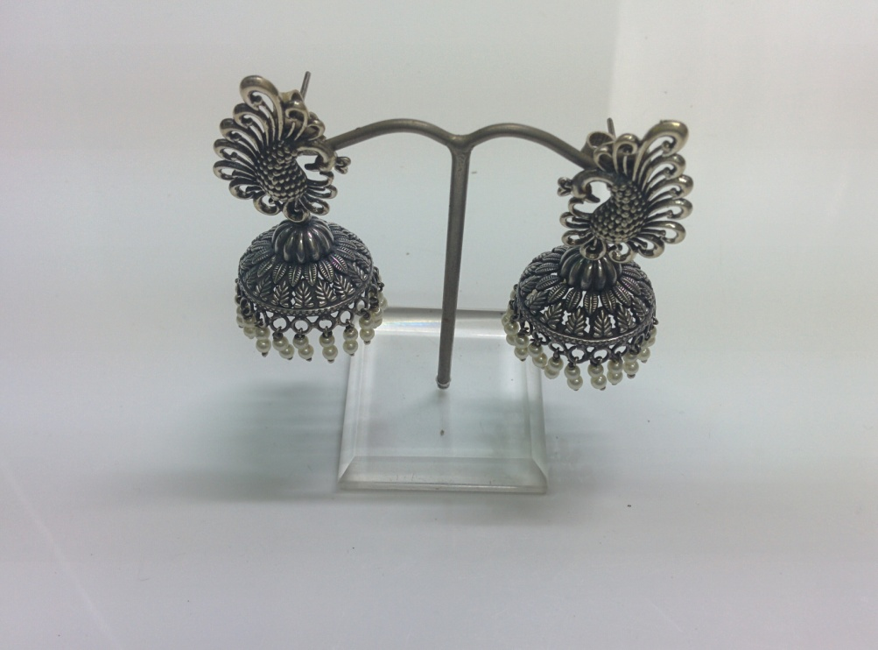
Sr No. – LWE12 Wght: 19.3 gms

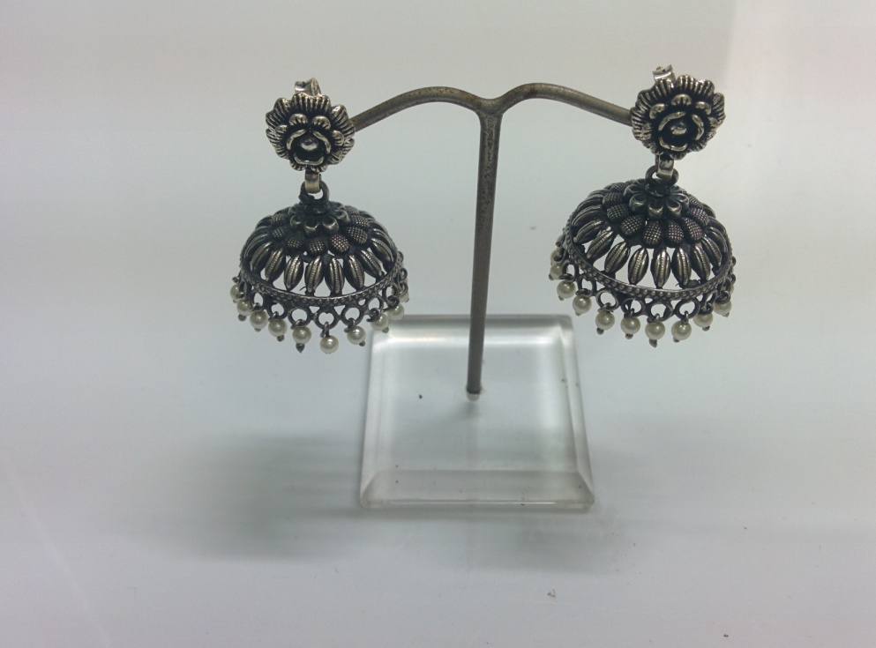
Sr No. – LWE13 Wght: 14.5 gms

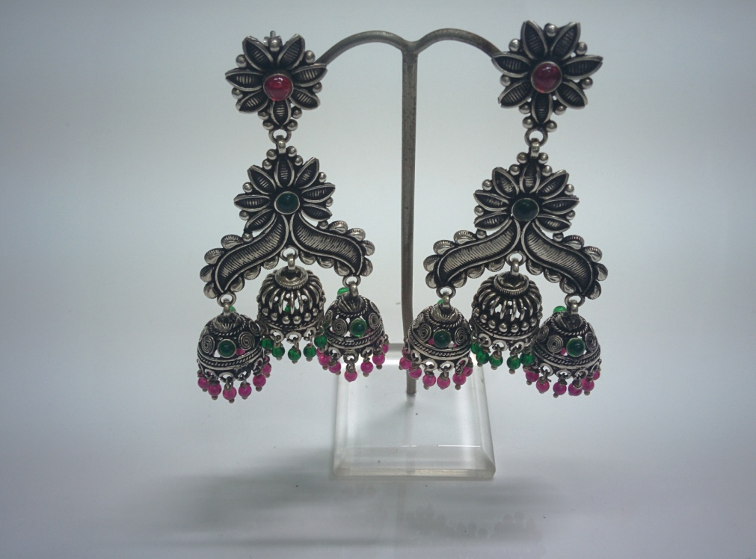
Sr No. – LWE14 Wght: 46.9 gms

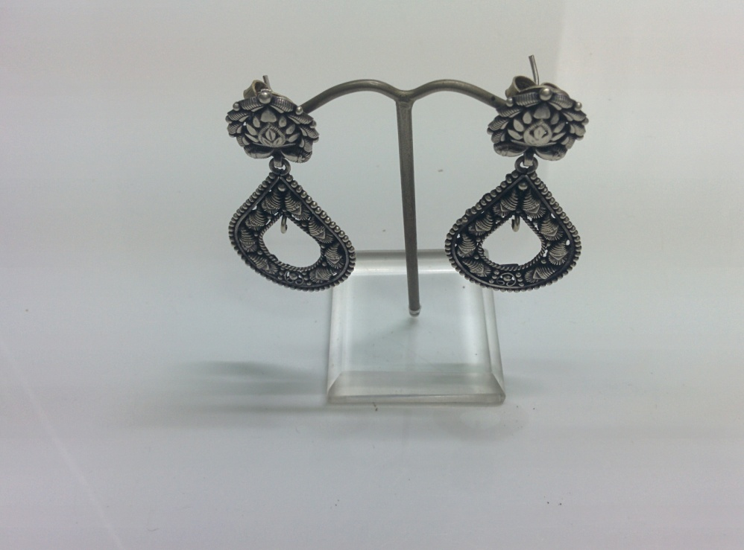
Sr No. – LWE15 Wght: 15.2 gms

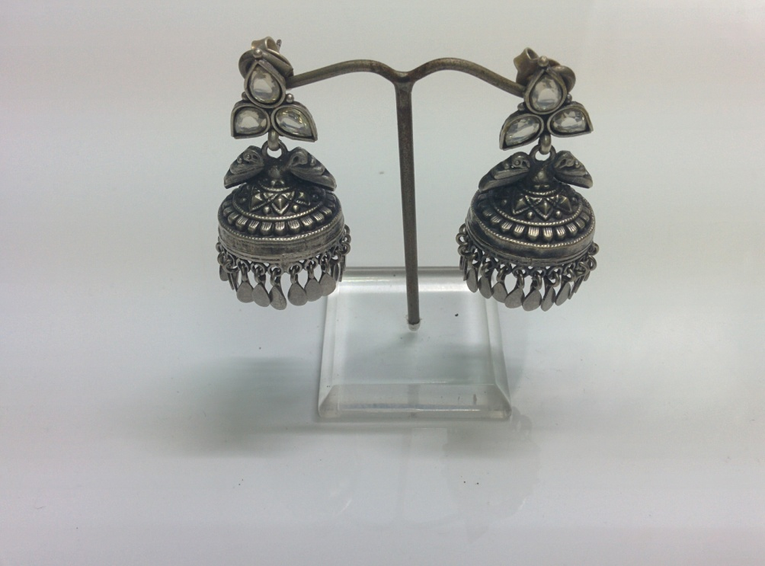
Sr No. – LWE16 Wght: 25.1 gms

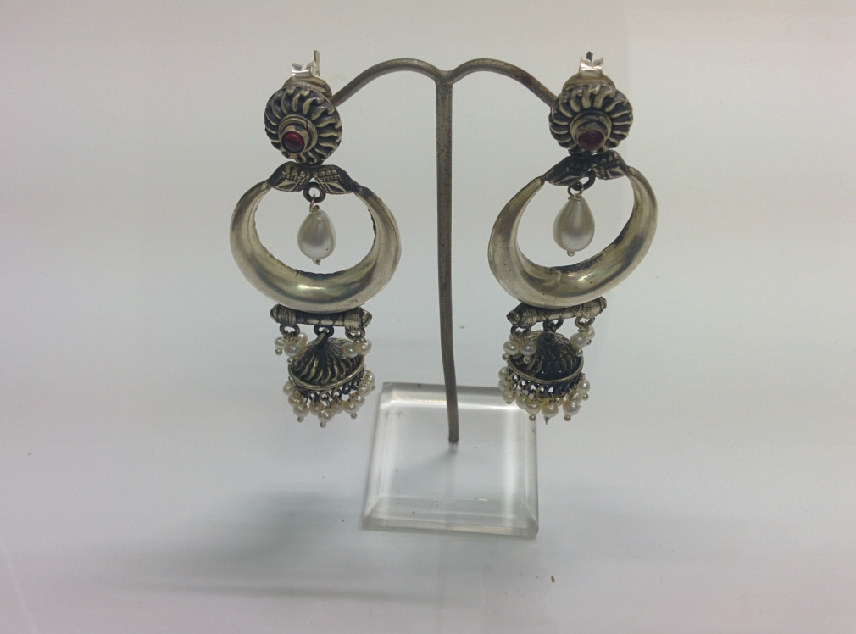
Sr No. – LWE17 Wght: 26.2 gms

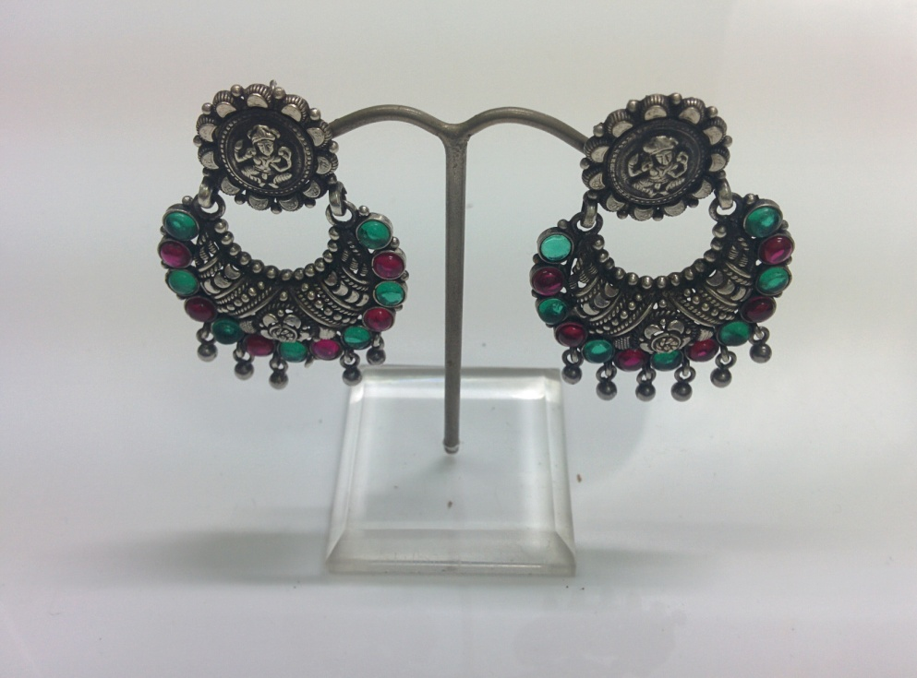
Sr No. – LWE18 Wght: 20.7 gms

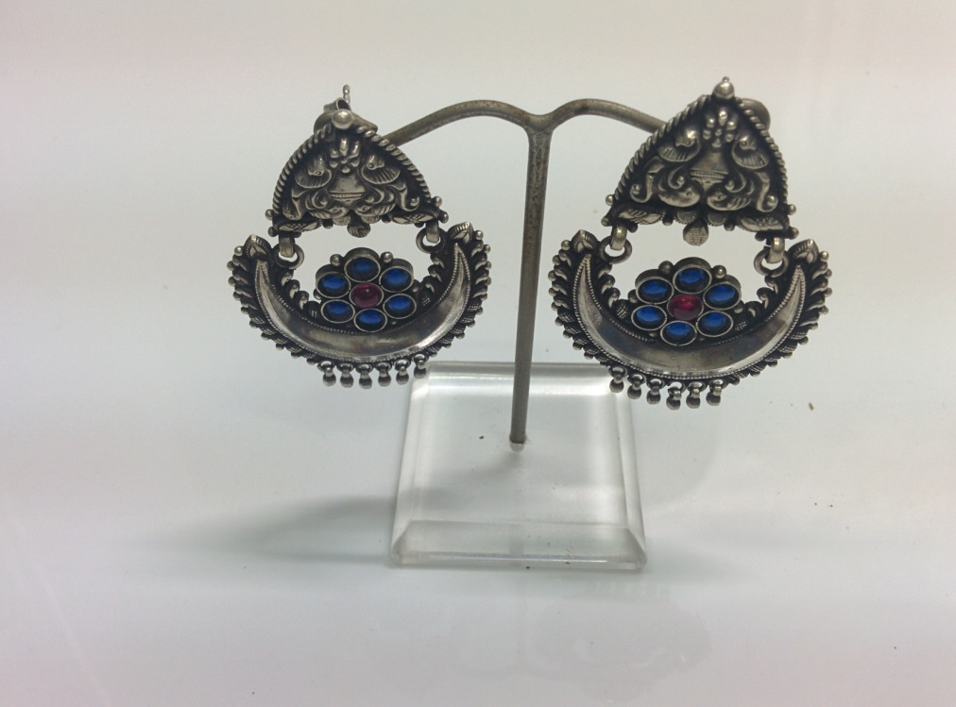
Sr No. – LWE19 Wght: 20.4 gms

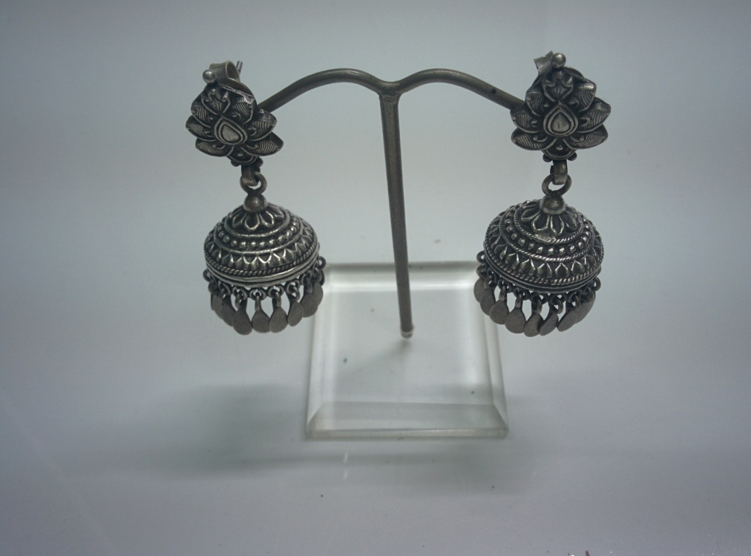
Sr No. – LWE20 Wght: 18.8 gms

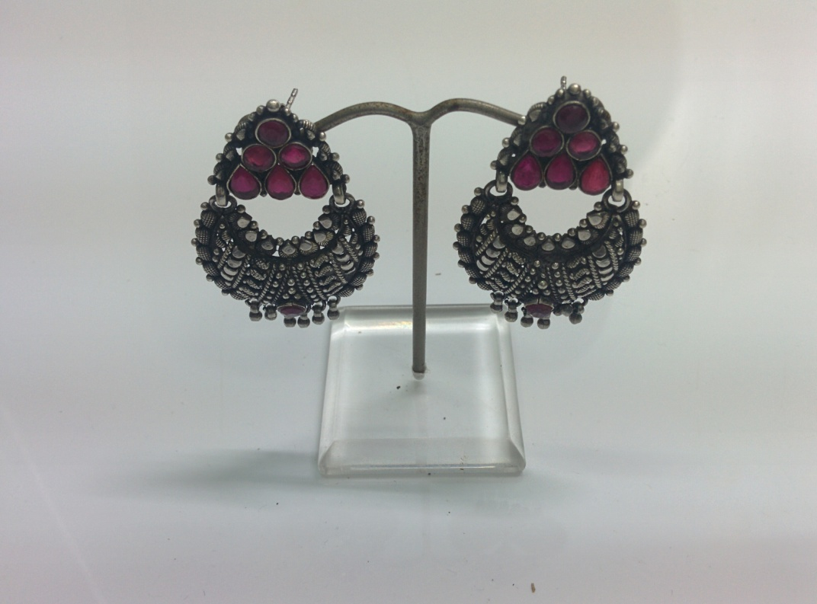
Sr No. – LWE21 Wght: 17.3 gms

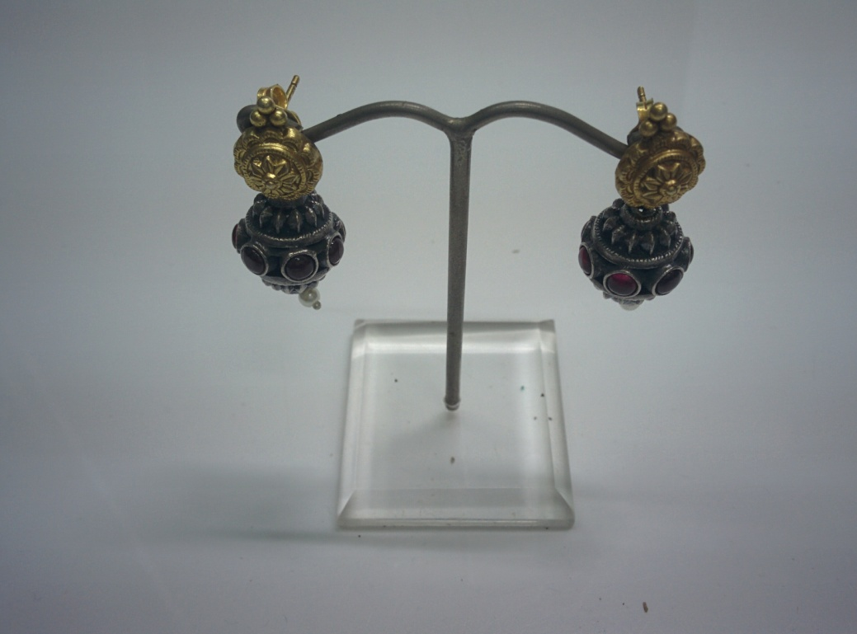
Sr No. – LWE22 Wght: 11.5 gms

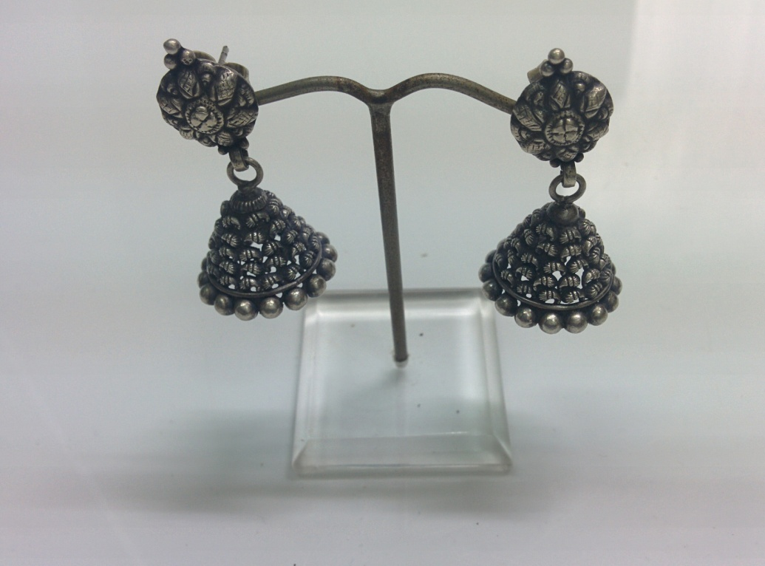
Sr No. – LWE23 Wght: 15.4 gms

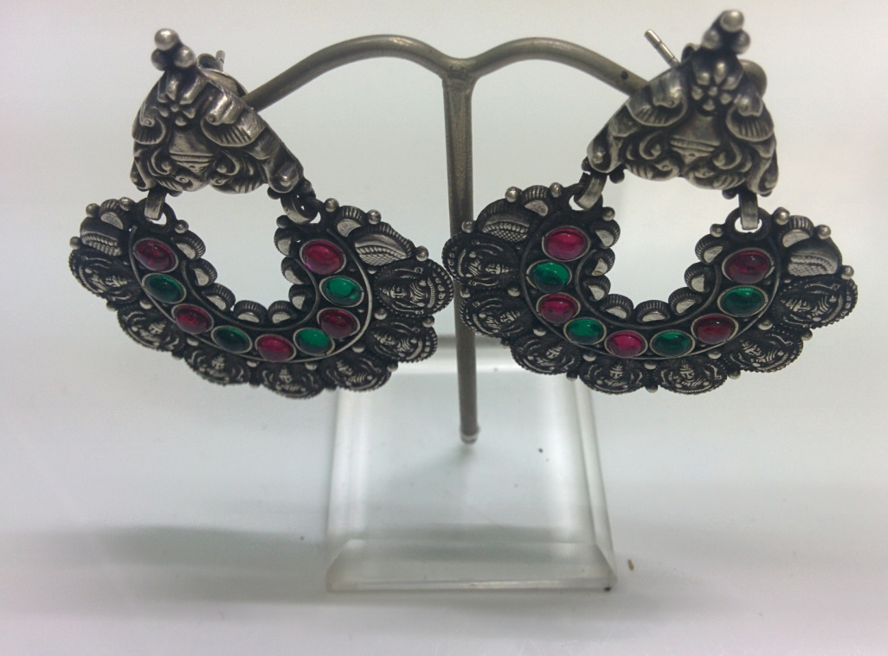
Sr No. – LWE24 Wght: 21.2 gms

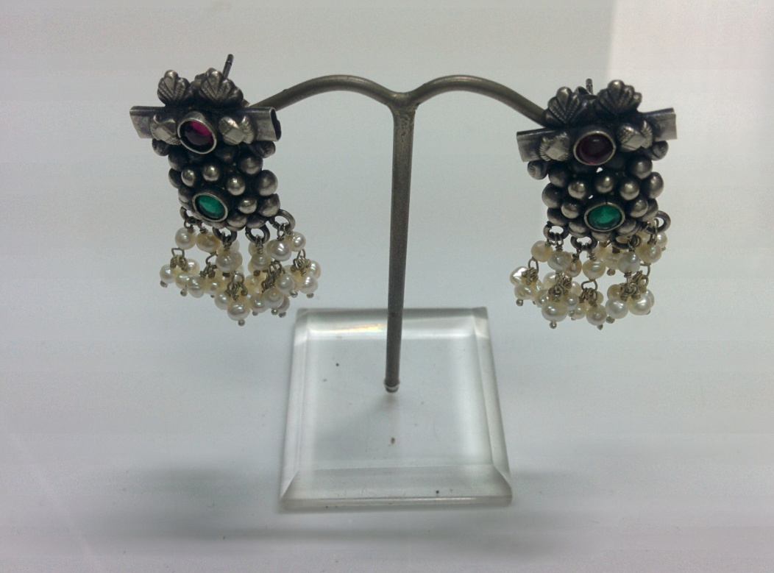
Sr No. – LWE25 Wght: 11.9 gms

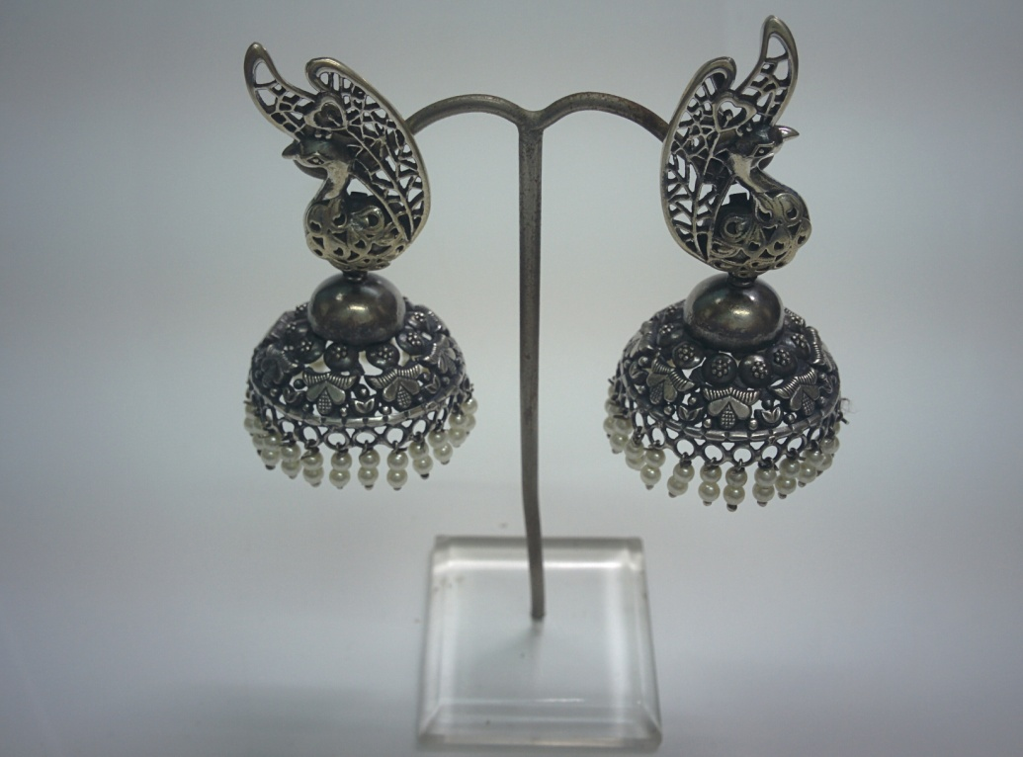
Sr No. – LWE26 Wght: 24.8 gms

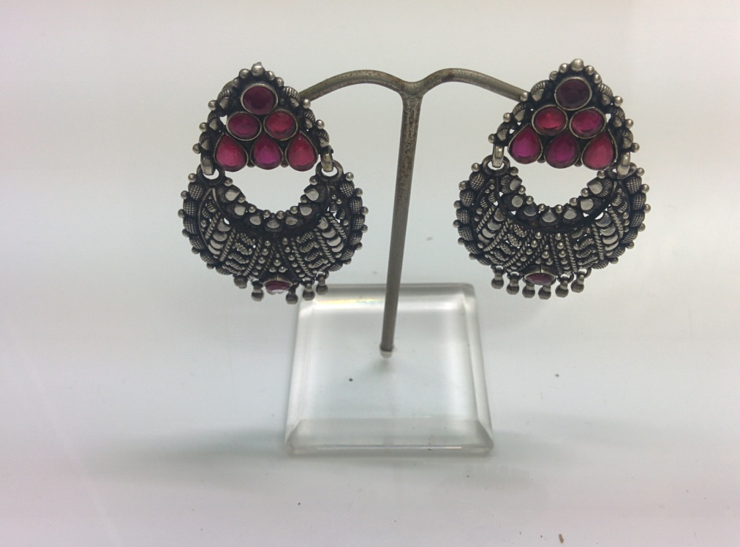
Sr No. – LWE27 Wght: 17.1 gms

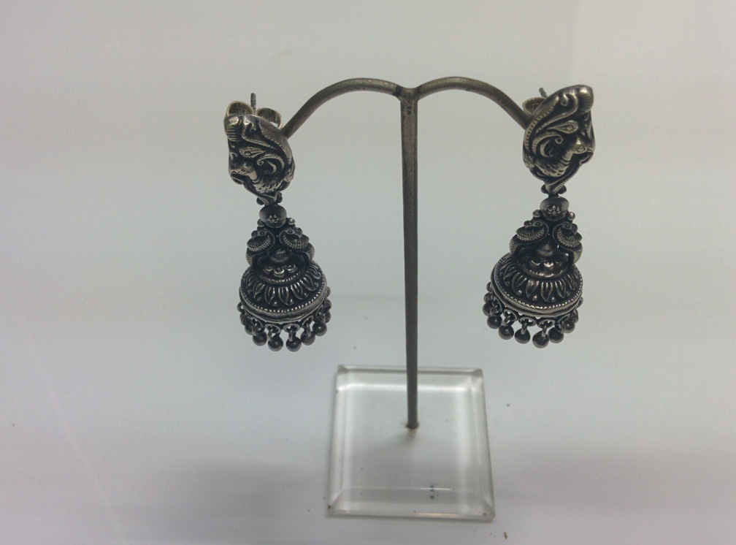
Sr No. – LWE28 Wght: 16.1 gms

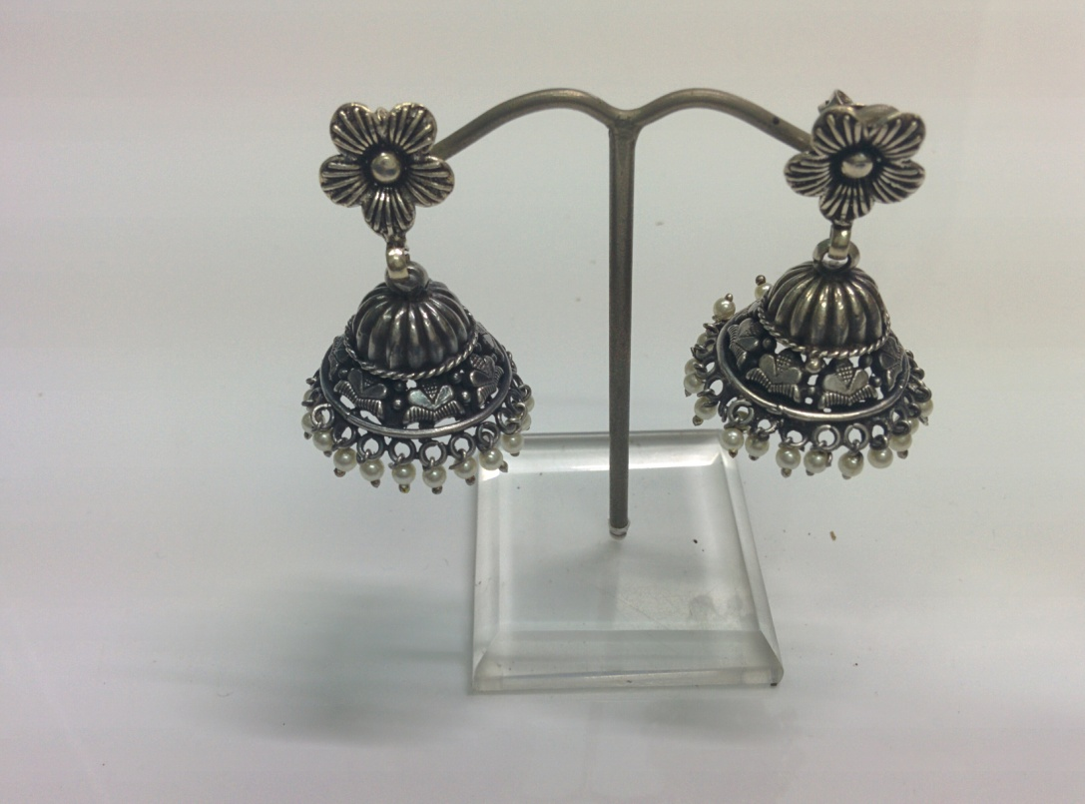
Sr No. – LWE29 Wght: 14.6 gms

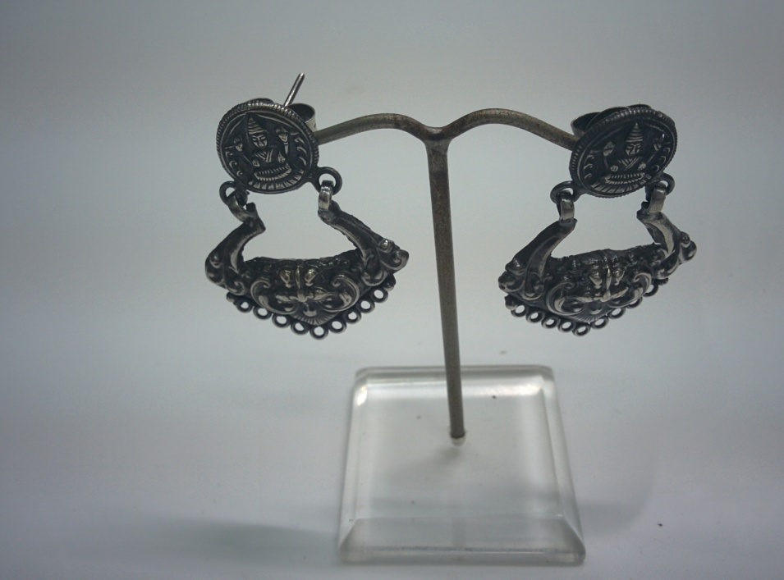
Sr No. – LWE30 Wght: 11.2 gms

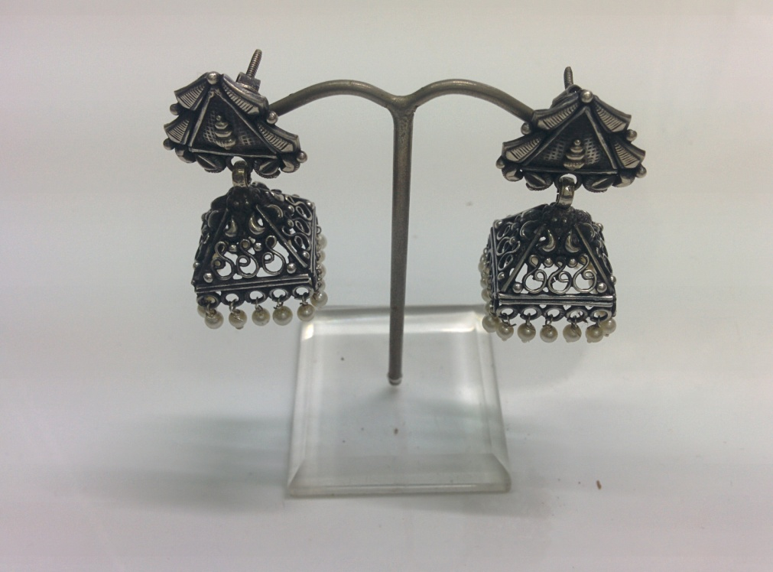
Sr No. – LWE31 Wght: 11.2 gms

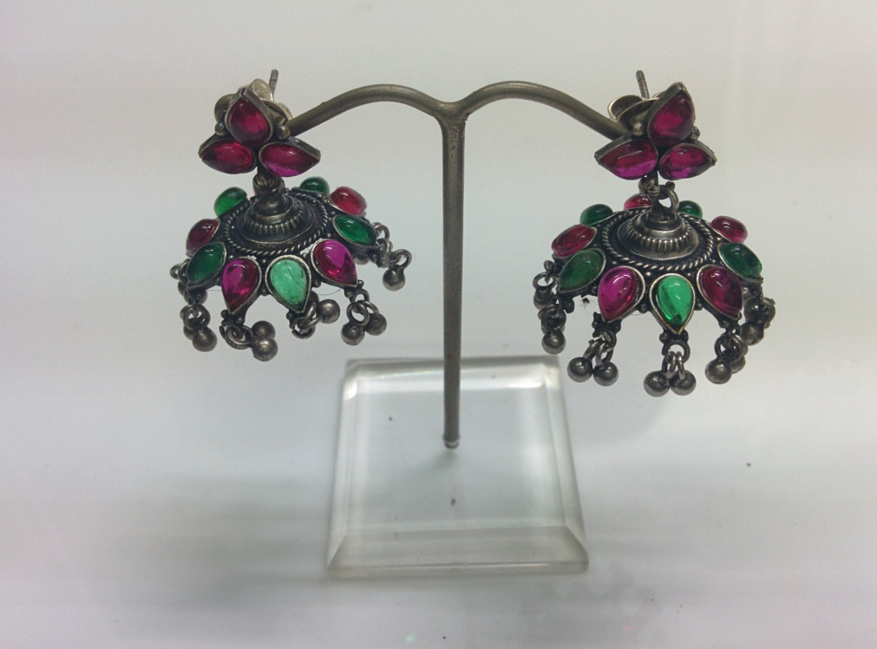
Sr No. – LWE32 Wght: 16 gms

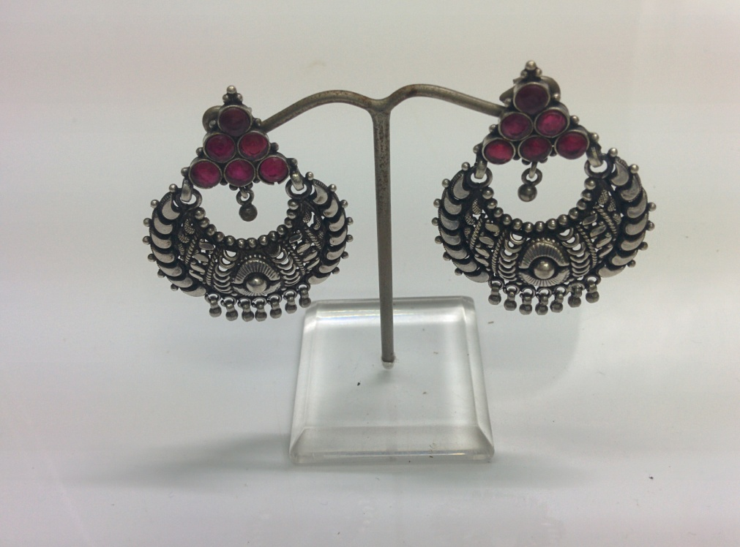
Sr No. – LWE33 Wght: 18.3 gms

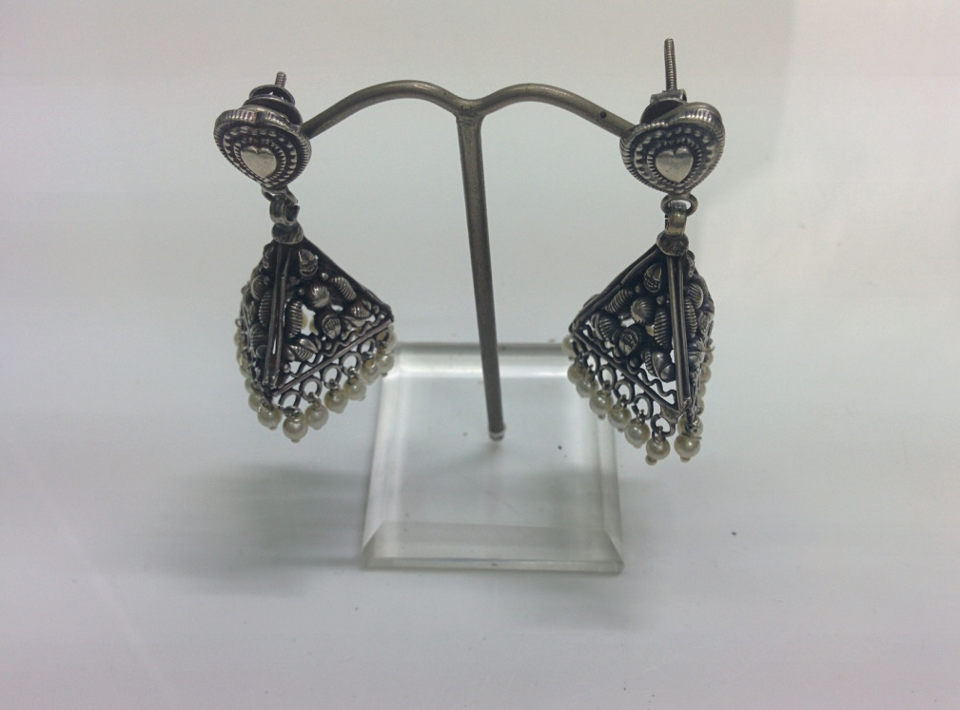
Sr No. – LWE34 Wght: 16.2 gms

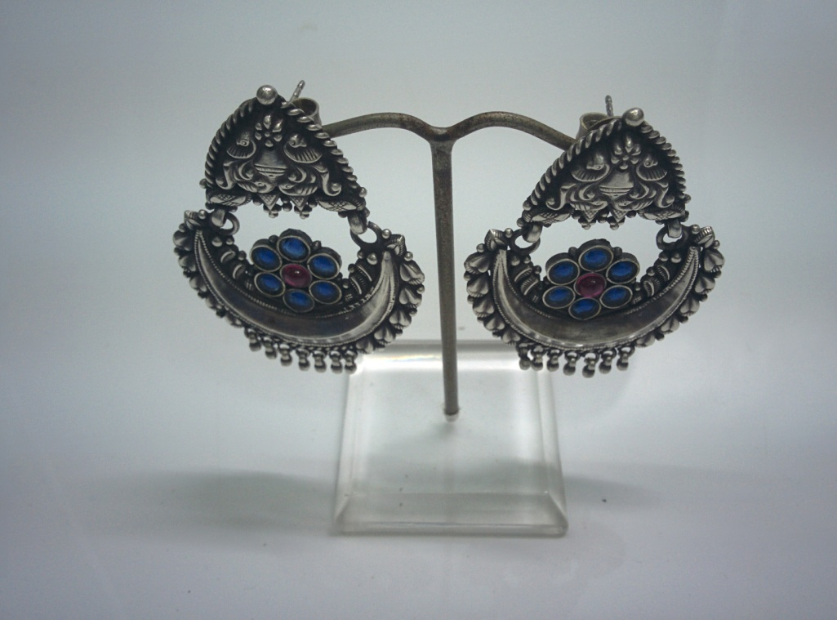
Sr No. – LWE35 Wght: 22.7 gms

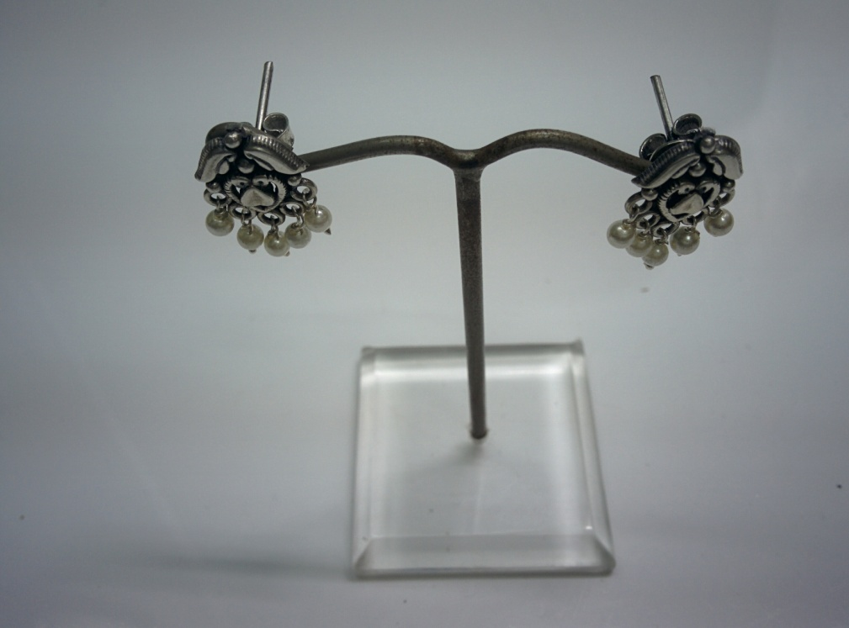
Sr No. – LWE36 Wght: 3.1 gms

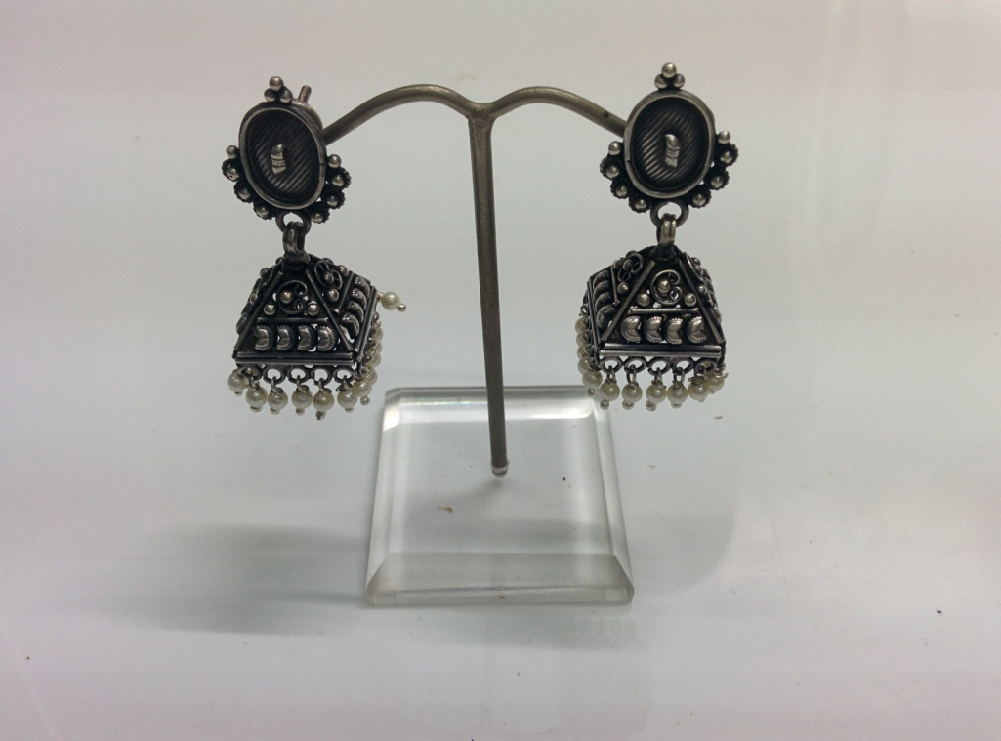
Sr No. – LWE37 Wght: 17.2 gms

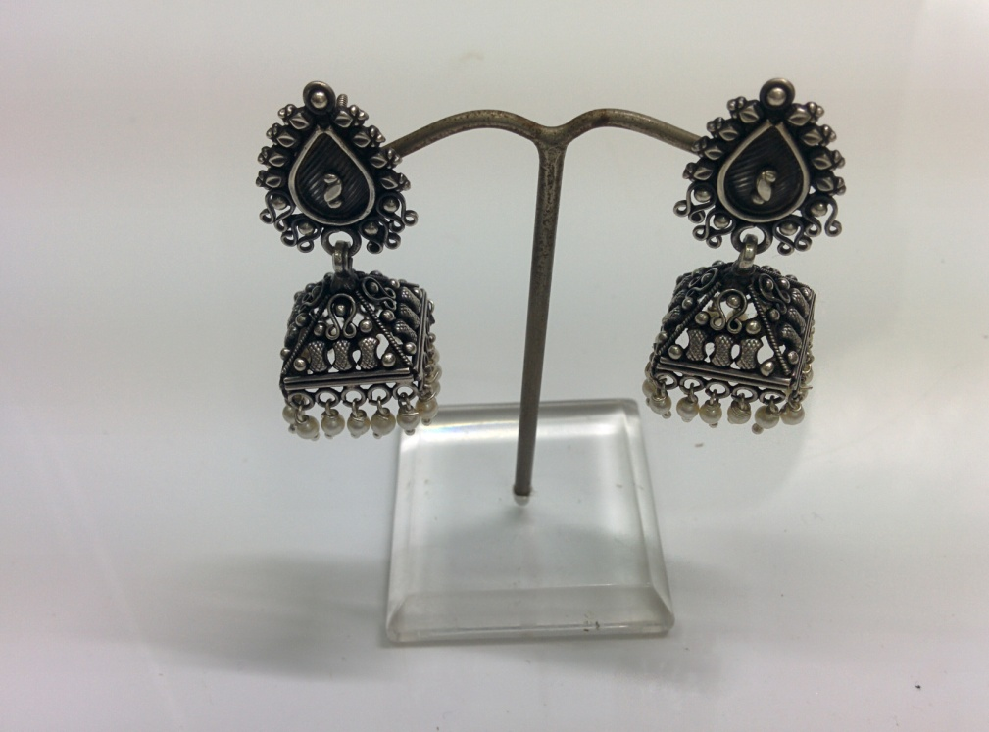
Sr No. – LWE38 Wght: 16 gms

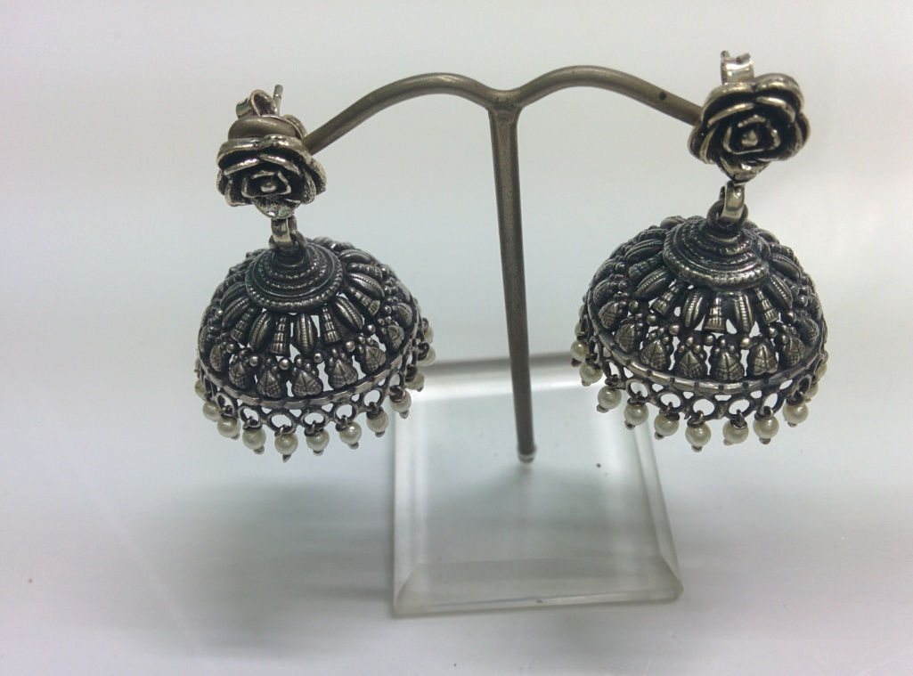
Sr No. – LWE39 Wght: 17.2 gms

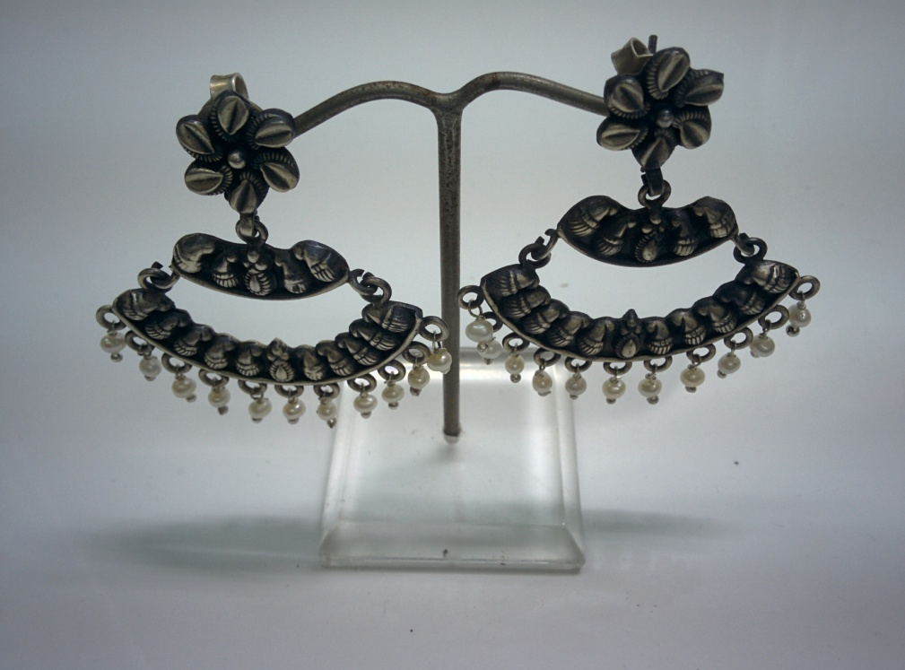
Sr No. – LWE40 Wght: 17.5 gms

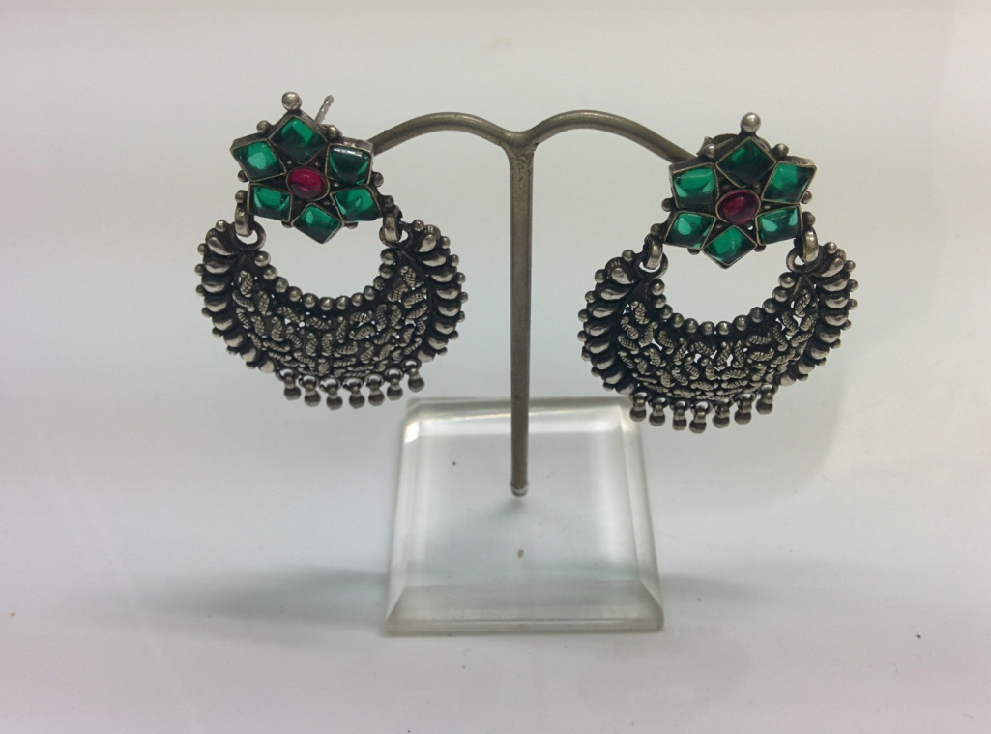
Sr No. – LWE41 Wght: 17.3 gms

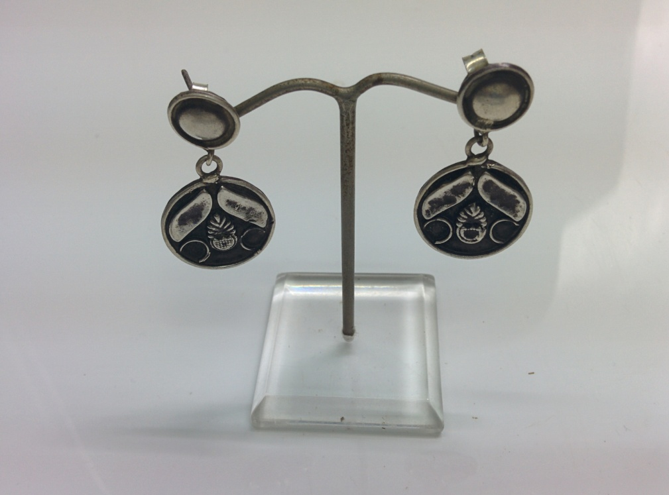
Sr No. – LWE42 Wght: 7.8 gms

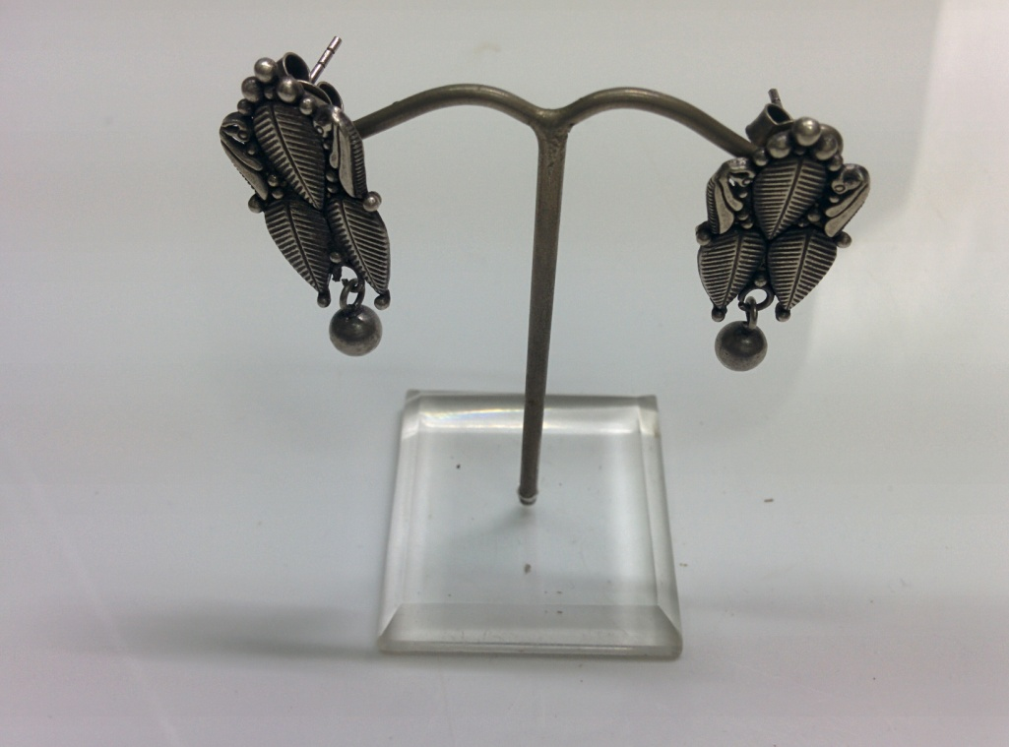
Sr No. – LWE43 Wght: 6.4 gms

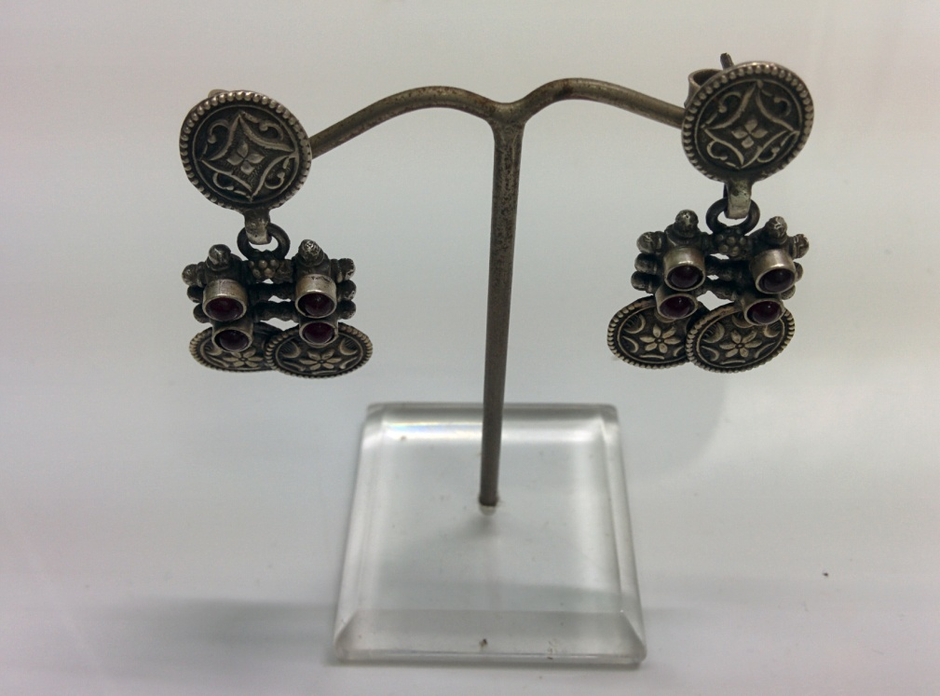
Sr No. – LWE44 Wght: 12 gms

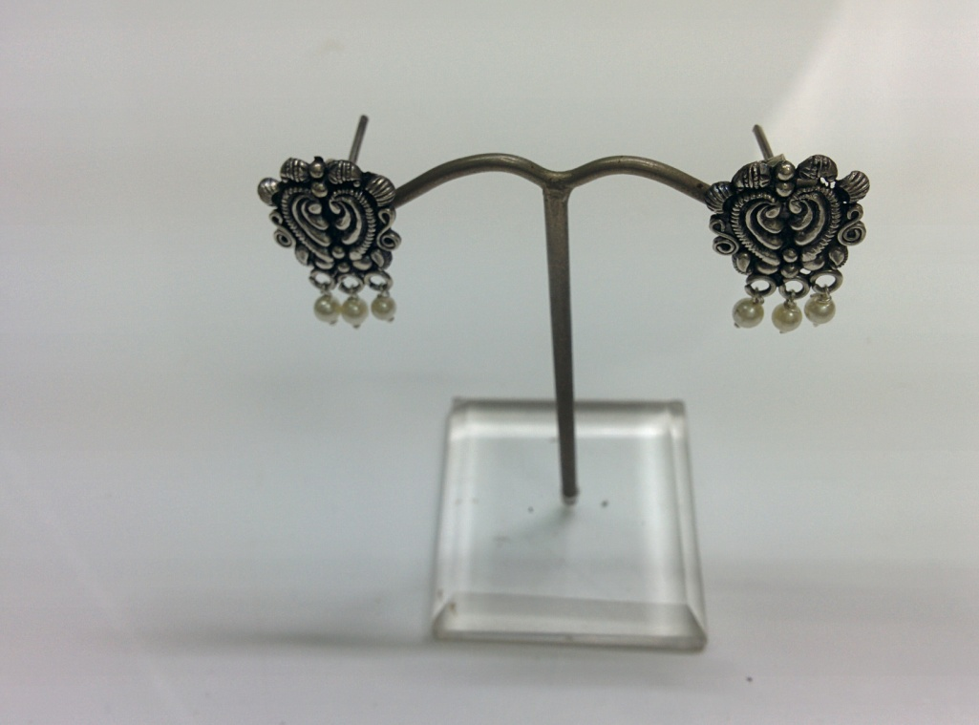
Sr No. – LWE45 Wght: 4.5 gms

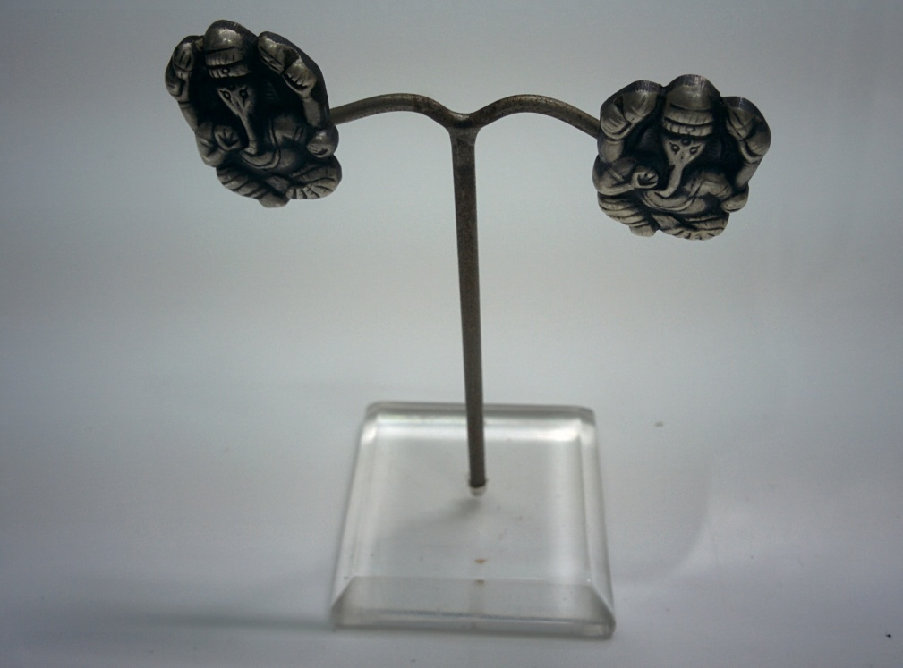
Sr No. – LWE46 Wght: 8.6 gms

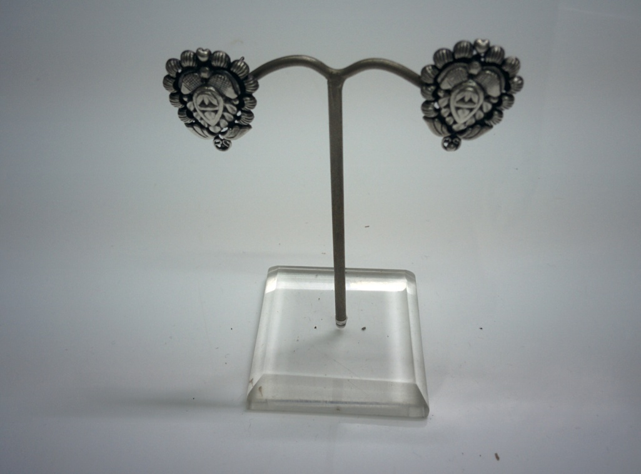
Sr No. – LWE47 Wght: 3.6 gms

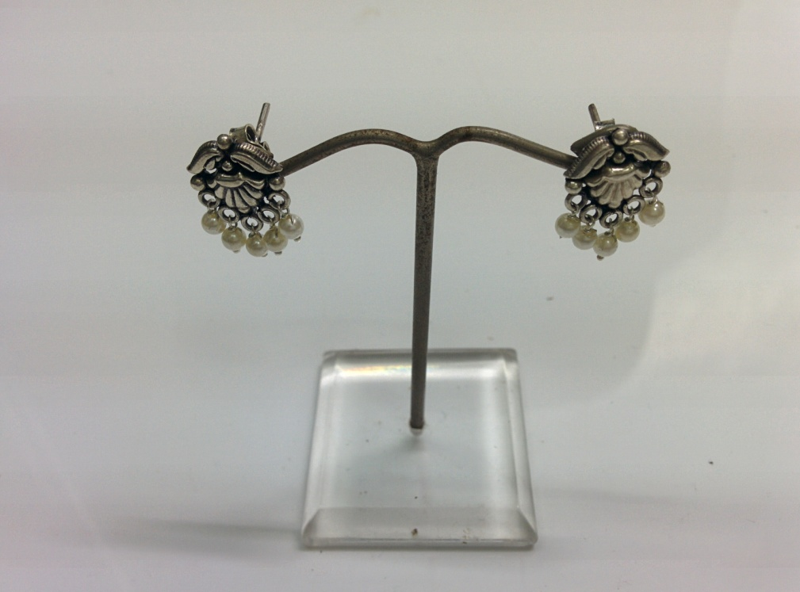
Sr No. – LWE48 Wght: 3.6 gms

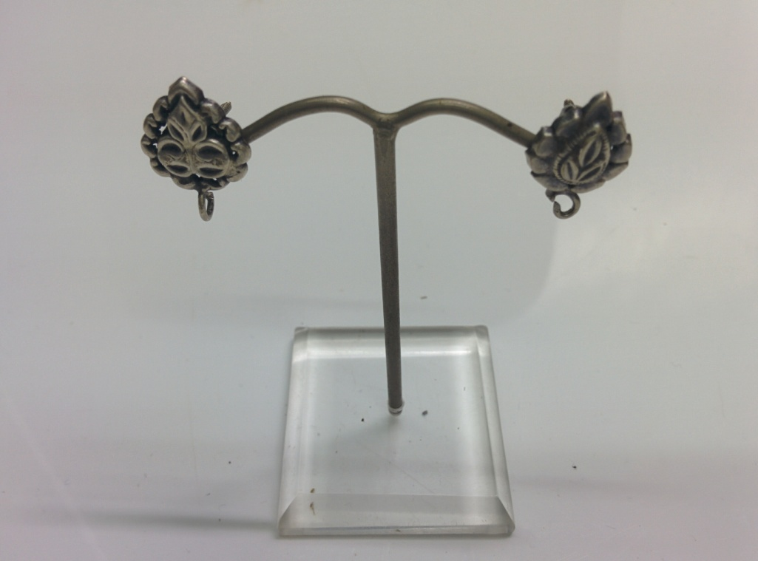
Sr No. – LWE49 Wght: 3 gms

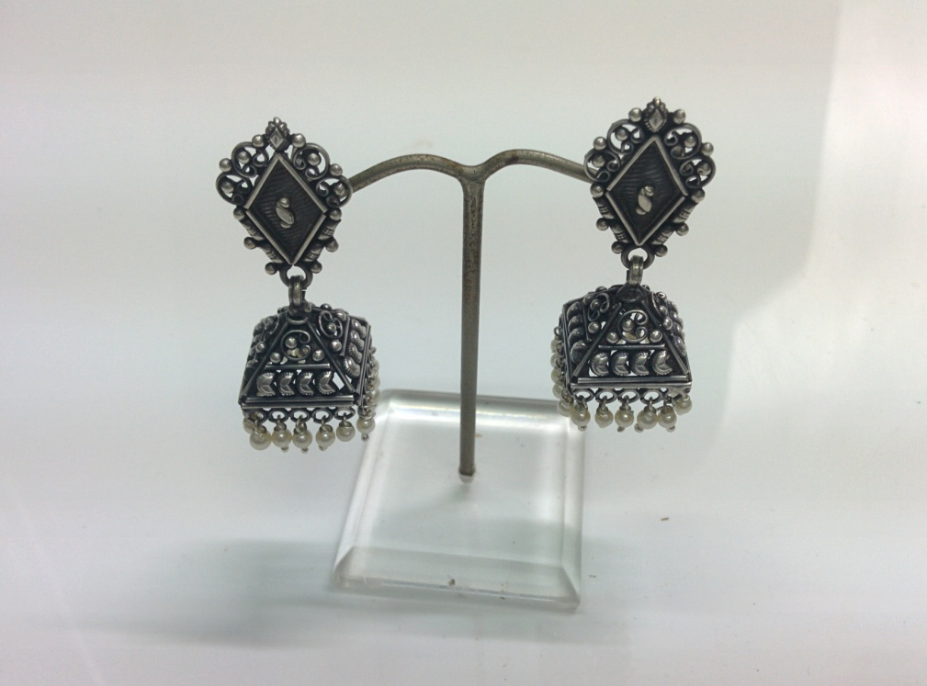
Sr No. – LWE50 Wght: 17.7 gms

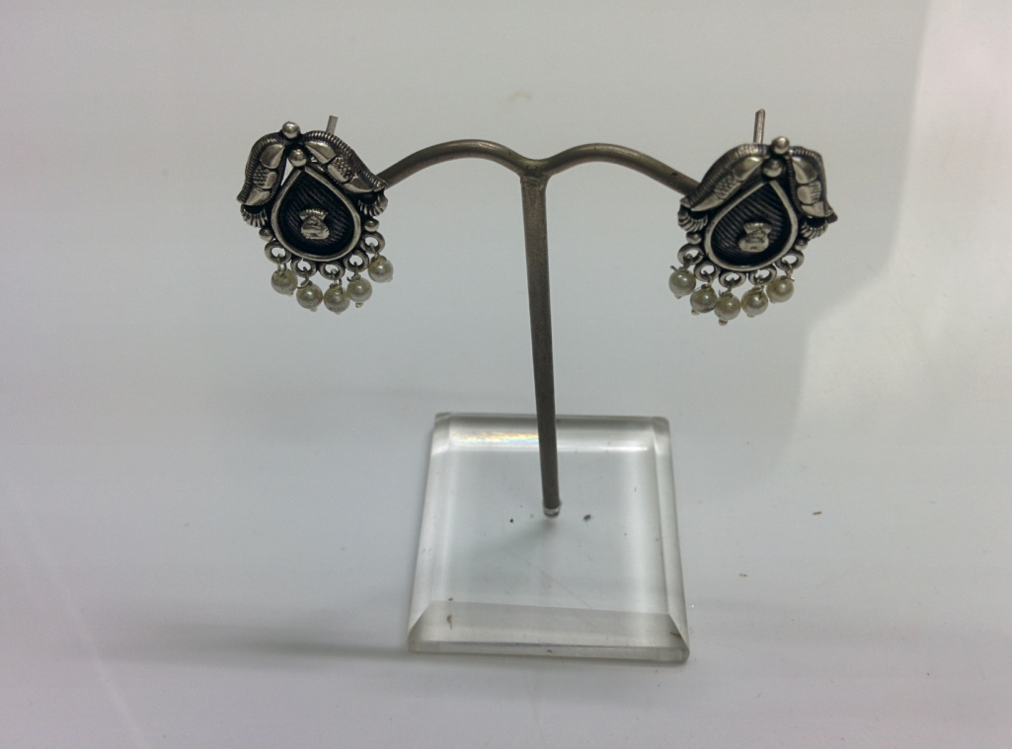
Sr No. – LWE51 Wght: 4.8 gms

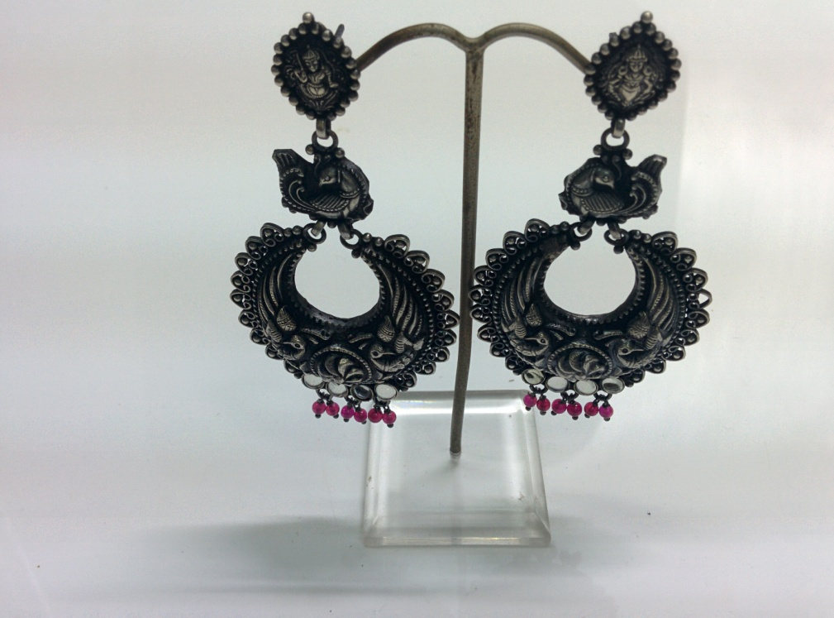
Sr No. – LWE52 Wght: 30.7 gms

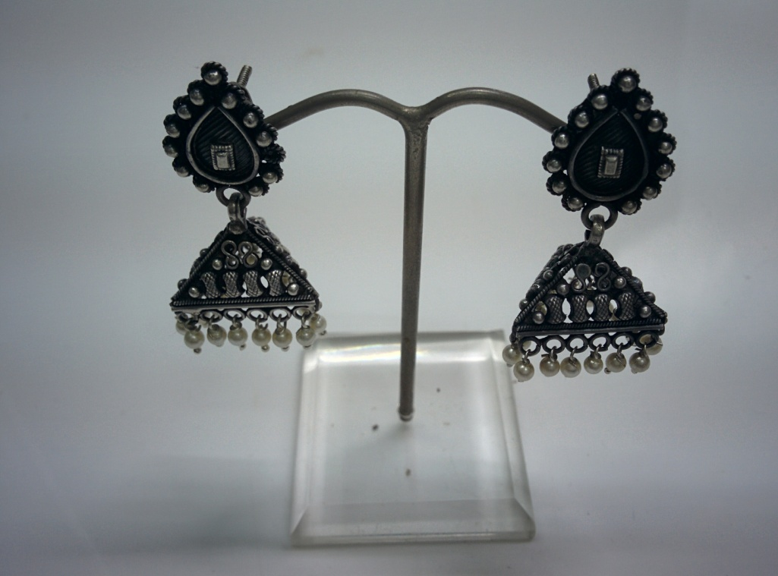
Sr No. – LWE53 Wght: 14.5 gms

- Weights mentioned are approximate weights, actual weight may worry by 1 / 2 gms.
- More designs available in each category, photos can be shared on demand.
- Try sending your selection at earliest to get the best designs available for your customers.
THANK YOU

